Diamond Valley Chiropractic and Health Clinic
205 Centre Avenue Black Diamond, AB. T0L 0H0
Phone: 403-933-3088

MASSAGE/CRANIOSACRAL/LYMPH DRAINAGE/ LaSTONE THERAPY/REFLEXOLOGY INTAKE FORM

Name: _________________________________________________________________Date: _____________________________________
Address: _______________________________________________________________Postal Code: ________________________________
Phone (Day): ________________________ (Evening): __________________________ (Cell): _____________________________________
Date of Birth: ______________________________________ Occupation: ____________________________________________________
Email: ____________________________________________________________________________________________________________
Allergies: __________________________________________________________________________________________________________
Current Medications including over the counter and supplements: ___________________________________________________________
__________________________________________________________________________________________________________________
Family Doctor: _____________________________________ Phone: __________________________Permission to consult: Y N
Emergency Contact: ______________________________________________________ Phone: ___________________________________
How did you hear about us?: __________________________________________________________________________________________
Have you received a professional Massage/Craniosacral/Lymph drainage/ Lastone Therapy or Reflexology before?: (circle all that applies)
What did you like/dislike?: ____________________________________________________________________________________________
Do you have any difficulty lying on your back, front or side? (circle all that applies)Explain: _______________________________________
Do you have allergies to oils, lotions or ointments?: (circle all that applies)Explain:______________________________________________
Are you wearing contact lenses?: Y N dentures?: Y N a hearing aid?: Y N Do you sit for long periods of time?: Y N
Do you perform repetitive movements in work, sports, hobby?: (circle all that applies) Explain: ___________________________________
Do you experience stress in your work, family or others aspects of your life?: (circle all that applies)Explain:__________________________
__________________________________________________________________________________________________________________
Put the appropriate Letter beside the symptom you may now or previously had: P - for Past R - for Reoccurring C - for Current

Musculosketetal Skin Digestive
Bone or Joint Disease ____ Dryness ____ Constipation ____
Tendonitis _____ Bruise easily ____ Diarrhea ____
Bursitis _____ Allergies ____ Gas/Bloating ____
Broken/fractured bones ____ Rashes ____ Diverticulitis ____
Osteoarthritis ____ Athletes foot ____ I.B.S. ____
Rheumatoid arthritis ____ Warts ____
Neck/ whiplash/shoulder/arm injury ____ Psoriasis ____ Nervous System
Back/hip/leg injury ____ Eczema ____ Numbness/Tingling ____
Osteoporosis ____ Fatigue ____
Jaw/TMJ or ear pain ____ Circulatory Chronic pain ____
Headaches or migraine/ head injuries ____ Heart Condition ____ Herpes/ Shingles ____
Spasms/Cramps ____ Varicose Veins ____ Sleep Disorder ____
Lymphedema ____
Respiratory High/low blood pressure ____ Genito-Urinary
Chronic cough ____ Fainting or dizziness ____ Pregnant ____ if current # of weeks ____
Chest pain ____ Phlebitis ____ PMS ___
Asthma/Allergies____ Menopause ____
Difficulty breathing ____ kidney disease ____
Frequent/painful urination ____
Other Prostate trouble _____
Cancer/Tumors ___ Mental Health Condition ____
Fibromyalgia ____ Poor nutrition ____ Family Health History (relationship)
Epilepsy ____ Drug Consumption ____ Migraines ________________________
Nervous disorders ____ Nicotine _____ Arthritis _________________________
Crohn’s disease ____ Caffeine ____ Heart Disease _____________________
Pelvic inflammatory disease ____ Alcohol Consumption ____ Strokes __________________________
Diabetes ____ ________________________ Diabetes _________________________
Cancer ________________________

Did the current injury result from a motor vehicle accident or workplace injury?: Y N
Have you had any of the following regarding your current condition: (circle)
physician’s examination x-ray other diagnostic tests: ____________________________________________
Are you currently under medical supervision?: Y N Explain: _____________________________________________________________
Do you see a chiropractor/ physiotherapist?: Y N
Have you had surgery in the past? Y N If yes, when and for what?: ______________________________________________________
__________________________________________________________________________________________________________________
Have you taken any pain killers in the last 24 hours?: Y N type:__________________________________________________________
Reason/goals for this treatment: _______________________________________________________________________________________
Are you in Pain?: Y N When did it begin?:____________________ Location of pain:__________________________________________
What relieves your pain?:_____________________________________________________________________________________________
What aggravates your pain?: __________________________________________________________________________________________
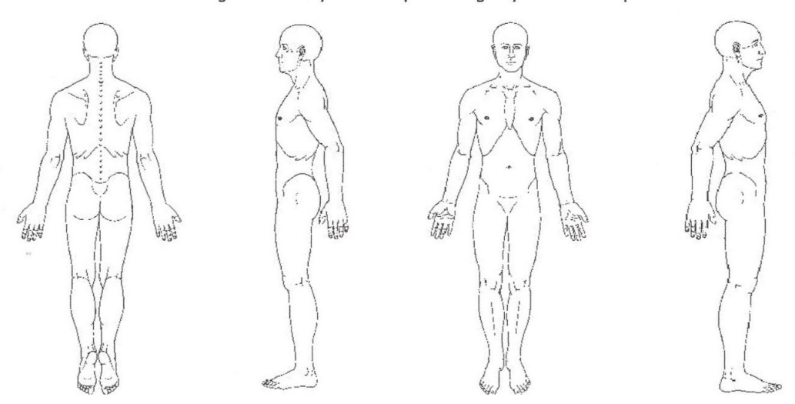
Please circle area(s) of pain
“X” over areas of stiffness
Draw a squiggly lines along areas of
Numbness, tingling, or altered sensation
Explain if necessary: ______________________
_______________________________________
_______________________________________
_______________________________________

INFORMED CONSENT TO MASSAGE THERAPY TREATMENT
I understand that the massage therapist is providing massage therapy services within their scope of practice as defined by their professional membership. I acknowledge that the therapist is not a physician and does not diagnose illness or disease or any other physical or mental disorder. I clearly understand that massage therapy is not a substitute for a medical examination. It is recommended that I attend my personal physician for any ailments that I may be experiencing. I acknowledge that no assurance or guarantee has been provided to me as to the results of the treatment. I acknowledge that with any treatment there can be risks and those risks have been explained to me and I assume those risks.
I acknowledge and understand that the therapist must be fully aware of my existing medical conditions. I have completed my medical history form as provided by my therapist and disclosed to the therapist all of those medical conditions affecting me. It is my responsibility to keep the massage therapist updated on my medical history. The information I have provided is true and complete to the best of my knowledge.
I hereby consent for my therapist to treat me with massage therapy for the above noted purposes including such assessments, examinations and techniques, which may be recommended, by my therapist.
I authorize my therapist to release or obtain information pertaining to my condition(s) and/or treatment to/from my other caregivers or third party payers.
I have read the above noted consent and I have had the opportunity to question the contents and my therapy. By signing this form, I confirm my consent to treatment and intend this consent to cover the treatment discussed with me and such additional treatment as proposed by my therapist from time to time, to deal with my physical condition and for which I have sought treatment. I understand that draping will be used during the session, and only the area being worked on will be uncovered. At any time I may withdraw my consent and treatment will be stopped.
Clients under the age of 18 years must be accompanied by a parent/guardian during the entire session unless waived by the parent/guardian.

Patient Name ______________________________________ Signature of Patient/Guardian _____________________________________
As parent/guardian, I agree not to be present during session (Initial) _______________________

Witness __________________________________________________________ Date Signed ______________________________________

